SPEAK ABROAD

- Home
- About
- Study in India
- Study Abroad
- FAQ

Home

Two partitions
Example:

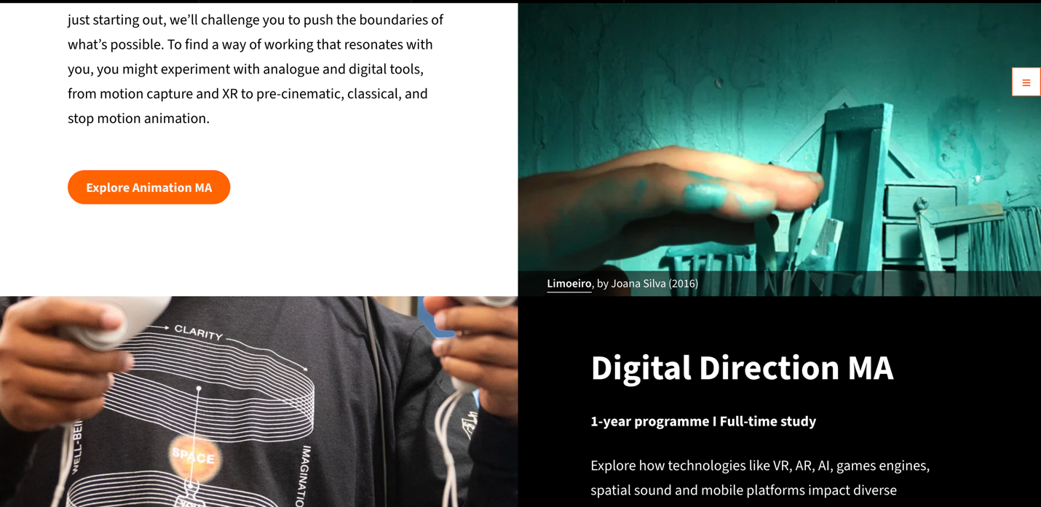

Partition one study in india

“One vision. Unlimited destinations. Infinite opportunities “
Step into a future shaped by excellence. Gain access to world-class education, experience a vibrant and diverse culture, and explore limitless academic and career opportunities in one of the world’s fastest-growing economies. Your global journey starts here.

Patition two Study Abroad

Study Abroad
“• Let your ambitions rise beyond boundaries and transform into global success..”
Expand your horizons with an international education designed to shape global leaders. Discover new cultures, gain globally respected qualifications, and build a career without boundaries. Experience innovative teaching, advanced research opportunities, and a truly international network that prepares you for success anywhere in the world.
Start your global chapter today.

Note : back ground live videos or images regarding the reference of both India and Uk -culture based
Intention is to indicating the culture and tradition of both ..
For instance ,


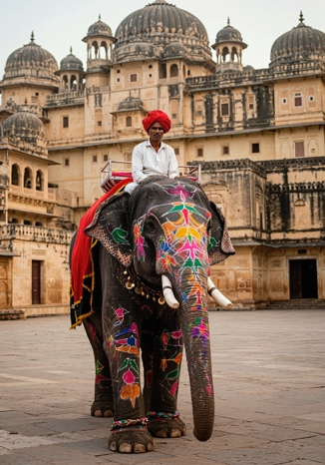

- Contact us , --No change

- Remove - Courses and We offer also from the home page

- fAQ will provide Later

- Remove
- 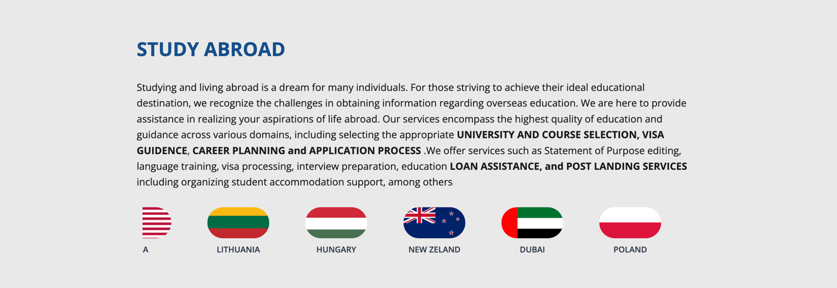
Add icons of newly added countries

- Top universities &courses --- Testimonials
( Leave the both sections below will provide the content later )
